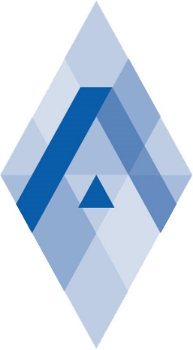
State Educational Institution of Higher Education
KOMI REPUBLICAN ACADEMY OF STATE SERVICE AND ADMINISTRATION
with the support of the Russian Foundation for Basic Research and
Government of the Republic of Komi
holds on 18-19 October, 2017

All-Russian scientific Conference “The European area of the Russian Arctic: development scenarios "

The conference is of scientific and application-oriented nature and is directed to development of strategic priorities in solving social and economic problems of the Komi Republic. The wide range of the touched subjects is caused by the specific living conditions in a zone of the Russian Arctic and also in the territories of the Far North and equated to them.

The set of historical and climatic conditions leave a certain mark on practically all spheres of human life in the North that allows to build the conference around on the following main problems:
- Priority development area (PDA): principles and conditions for the Arctic monocities development;
- Formation of support zones for the development of the Arctic and ensuring their functioning;
- Water transport: cost-effectiveness analysis and the role of water arteries of the North in preserving biosphere diversity and ecological balance;
- Scientific cooperation in the development of the oil and gas sector (with the invitation of representatives of the scientific and industrial sector of the Nenets Autonomous District, the Republic of Tatarstan, etc.);
- Scientific and applied cooperation in the issues of information, management and power interrelation, development of information and communication technologies in the public and non-public sectors (technological perspectives of using information and communication technologies in management);
- Strategic objectives of the development of the agricultural sector in the Northern Territories of Russia, as well as the development of the green economy in Komi;
- Development of social entrepreneurship; analysis of a new form of market relations as a socio-economic phenomenon and legal category;
- Law enforcement practice in the field of environmental law; development and adoption of legislative acts regulating liability for environmental pollution, compensation for damage and costs for its restoration, as well as regulating mutually beneficial cooperation conditions between resource companies and the public;
- Building of an effective system for managing the use of the environment of the North areas with a delimitation of powers in the field of public administration between federal, regional and local government authorities; creation of institutes of inter-regional growth (cooperation);
- Development of new knowledge-intensive and technological activities that contribute to the minimization of the colonial use of raw materials and the transition to alternative natural resource management mechanisms, including support for resource-saving and resource-substituting environmentally and economically rational economic activities;
- Preservation and promotion of favorable conditions for natural reproduction of biological resources, protection of flora and fauna of the Northern and Arctic territories;
- Support of scientific developments and educational programs in the field of ecology, environmental protection and rational natural resource management in the North;
- Development and systematic implementation of the system of continuous vocational education for the strategic provision of specialists with the skills necessary for work in the territories of the North and the Arctic;
- The issues of merger and enlargement of the Northern Subjects of the Russian Federation.

At the end of the Conference, the collection of articles will be published and placed in the bibliographic database of the scientific publications of the Russian scientists ELIBRARY.ru (Russian Science Citation Index).
The program of the Conference will be sent to all the participants beforehand.
To participate in the Conference you must register till the 08.10.2017 at the Conference web-site https://krags.ru/conf/.
The Organizing Committee has the right to refuse the publication of the articles which are not relevant to the perspective of the Conference and also formatted with the violation of the rules.
If you have any questions, please contact: +7 (8212) 302780 (add. 130 - Dmitriy Popov), or e-mail: science@krags.ru.

