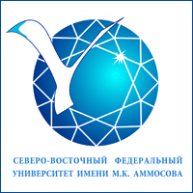
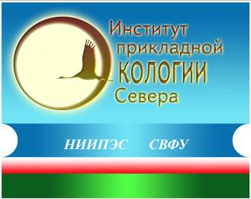
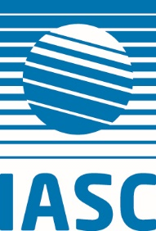
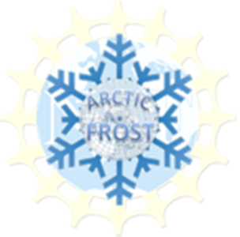

NSF Arctic-FROST Project
INTERNATIONAL ARCTIC SCIENTIFIC COMMITTEE
NORTH-EASTERN FEDERAL UNIVERSITY (NEFU)
INSTITUTE OF APPLIED ECOLOGY OF THE NORTH
Center for Sustainable Development of Territories

International workshop
«INDIGENOUS PEOPLES OF THE NORTH AND THE INDUSTRIAL DEVELOPMENT IN THE RUSSIAN ARCTIC:
APPROACHES TO BENEFITS SHARING»
(Yakutsk, 25-28 April 2018)

ANNOUNCEMENT

The Arctic-FROST research coordination network, International Arctic Science Committee, Institute of Applied Ecology of the North, NEFU and Center for Sustainable Development of Territories are pleased to invite you to attend the workshop in Yakutsk, Russian Federation (25-28 April 2018).
The workshop aims to provide a comprehensive view on the benefit sharing and compensation mechanisms for the indigenous peoples of the North due to industrial development in the Russian Arctic and beyond. The workshop will team together the experts on benefits sharing, corporate social responsibility, social-economic development, environmental sustainability, and Indigenous rights in the Arctic, as well as policy makers, representatives of business and local communities to discuss the perspectives on the benefit sharing between Indigenous peoples and subsoil users (including compensation and investment mechanisms, loss assessment, socio-economic agreements, partnerships, etc.).
The organizers welcome the following themes:
1. The impact of industrial development in the Arctic on the traditional territories.
2. The practice of implementing legislation to support Indigenous and local interests.
3. Methodology for assessing the losses of indigenous peoples of the North and mechanisms for their compensation.
4. Benefits sharing mechanisms in the Russian Arctic an internationally.

All participants:
- Will present their work at the workshop (all papers/presentations will be published online and considered for inclusion in the Arctic-FROST edited volume and Workshop proceedings indexing in RISC)
- Will participate in discussions and round tables with leading benefits sharing researchers and practitioner
Eligibility: an applicant shall be
- prepared make an oral presentation on the subject related to benefits sharing and Arctic communities and
- available to participate in all workshop activities.
We accept applications from eligible applicants from all countries, disciplines and institution types. Applications from Indigenous scholars and Arctic residents are especially encouraged.
Funding: all participants take the responsibility for their travel and accommodation costs. The NEFU will provide the invitation letter for visa support.
! The workshop does not suppose the distance participation.
Application Deadline: 15 January 2018
Language: Russian, English, simultaneous translation will be provided.
Application: submit extended abstract of your paper (500-750 words) and application form.
Send your applications and inquiries to ipes-08@mail.ru (Dr. Valeriy Velichenko, Institute of Applied Ecology of the North, NEFU) and contact@csdt.science (Dr. Violetta Gassiy, Center for Sustainable Development of Territories.

Application form

Last name: | Surname:
Position:
Organization
Citizenship
Mail address
Telephone
E-mail
Title of abstract
Type of presentation | Oral □ Poster □

The information about the workshop is available at http://s-vfu.ru/ and http://csdt.science

We are appreciated for sharing this announcement.

