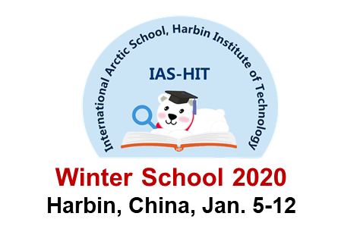
International Arctic School, Winter 2020
IAS-HIT-Winter2020

Second Announcement for the Winter School on:
To understand: Arctic Environment and Ecosystem
At Harbin Institute of Technology (HIT), Harbin, China
January 5-12, 2020

Organizers:

Harbin Institute of Technology (HIT), China
UArctic-HIT Training Centre, the University of the Arctic
Association of Sino-Russian Technical Universities (ASRTU)
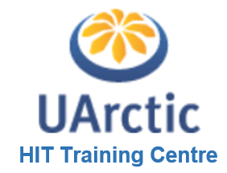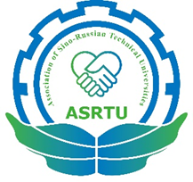
.

Co-Organizers:

Norwegian University of Life Sciences & University Center in Svalbard, Norway
North-Eastern Federal University, Russia

Introduction
The Arctic issue is not local, but global. Global warming in recent years has accelerated the melting of ice and snow in the Arctic region. As economic globalization and regional integration further develops and deepens, the Arctic is gaining global significance for its rising strategic, economic values and those relating to sea passages, natural resources, scientific research, and environmental protection as well.
As young generations and future elites in different disciplines and fields from China and the 8 Arctic countries, our goals on the Arctic are to understand, protect, develop and participate in the governance of the Arctic. To understand Arctic is the first step for protection, development and governance of the Arctic, and thus promotion of sustainable development of the Arctic. To understand the Arctic is to improve the capacity and capability in scientific research on the Arctic, to pursue a deeper understanding and knowledge of the Arctic science, and to explore the natural laws behind its changes and development, thus to create favorable conditions for mankind to better protect, develop, and govern the Arctic.
Sponsored by the International Project Office, Harbin Institute of Technology (HIT), The first Winter School to be held by the International Arctic School, HIT (IAS-HIT) on the topic of “To understand: Arctic Environment and Ecosystem” in the beautiful city of Harbin during January 5-12, 2020.
The teachers of the IAS Winter School come from the Arctic countries and China, and students will be from these countries and other countries too. The teaching courses will consist of core courses, lectures and laboratory courses. During the Winter School, the students will attend an international conference (Harbin Forum for Polar Environment and Ecosystem, HFPEE), and at weekend, the students can experience the beautiful Harbin City and world famous ice sculptures.
The language used in the Winter School is English.

Who can participate?
This Winter School invites graduate students from universities worldwide who love and care the Arctic and intend to achieve relevant scientific knowledge of the Arctic.
The following eligibility criteria apply:
- This program is open to students of all academic backgrounds;
- The student is motivated to enhance understanding and friendship among the students from different countries;
- The student must have sufficient knowledge of English, both oral and written, for academic studies.
The graduate students who are interested in attending the IAS-HIT-Winter2020 can apply by providing a short CV (about 200 words including email address and telephone number), a brief letter of interest, and description of what you hope to gain and contribute to the Winter School. The documents must be send to IAS_HIT@163.com.
Please note: Application deadline: October 31, 2019

Student fellowships
Accommodations and meals for attending students in Harbin during the Winter School period will be covered. A special scholarship will be available for one indigenous student upon separate application. The scholarship will include return trip flight tickets between Harbin, China and the nearest airport to the student’s home University (We will purchase the tickets for the student after approval). The students who apply for the special scholarship must write a short essay (~300 words) to introduce their community and approval of their indigenous status by their universities, which should be submitted along with all other needed documents.

Students are responsible for the following expenses:
- Personal travel insurance covering medical expenses, flight accidents etc.
- Costs for activities that is not part of the official program
- Costs for additional stay in China before or after the official program period, 4 January (check-in)-13 January (check-out), 2020
- Other personal expenses such as costs for issuing passport/visa and documentations needed for participating in the Winter School

Welcome to Harbin!

